[PSoC 4 Pioneer Kit Community Project#09 – Graphics LCD Display](http://www.element14.com/community/message/76334" \l "76334/l/psoc-4-pioneer-kit-community-project09-graphics-lcd-display)

 Today’s example project uses the a Graphical LCD Display Shield from Sparkfun which has a Nokia 6100 LCD. We’ve have tested this example on a number of shields that support the Nokia 6100 LCD:

[SparkFun Shield](https://www.sparkfun.com/products/9363)

[Elect Freaks](http://www.elecfreaks.com/store/color-lcd-shield-p-462.html)

[Nokia 6100 Shield](http://www.ebay.com/itm/Color-Image-LCD-Shield-for-Arduino-Nokia-6100-Display-Board-/110980386727?pt=LH_DefaultDomain_0&hash=item19d6f24fa7)

 There are minor differences between the boards for controllers and brightness controls. Please check with the datasheet of the additional LCD screens linked above to find out what controller is used. This example uses the Sparkfun Graphics LCD screen.

 What is unique about this example project is that we’ve created a custom Graphics LCD (GLCD) component in Creator that gives the user API controls for the LCD display. This component is not shipped with PSoC Creator as part of the general installation. The GLCD component is available in the attached example project and can be loaded into your design. This component creates an easy to use interface to write text and draw shapes on the LCD screen using APIs. Attached to this project is the Component Datasheet. In the datasheet we describe the APIs. The example project utilizes the APIs as an example. The following image is the project example output on the GLCD display. While the LCD output looks complicated you will see from the example that it uses simple APIs to create the shapes.

[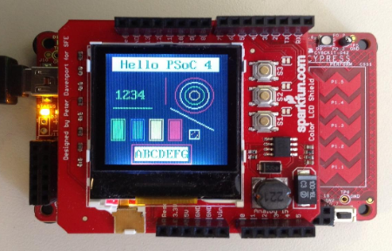](http://www.element14.com/community/servlet/JiveServlet/showImage/2-76334-146705/003+-+Example+Image.png)

(Pioneer Board with the Sparkfun LCD Shield)

 Additional Information on Custom Components:

 If people are interested in additional information on custom components please see the follwoing resources for more information:

[Implementing Programmable Logic Designs with Verilog](http://www.cypress.com/?rID=69773)

[Components with UDB Datapaths](http://www.cypress.com/?rID=69774)

 We also have a Knowledge Based Article that will assist users in creating a Verilog-based Custom Component:

[Creating a Verilog-based Component](http://www.cypress.com/?id=4&rID=76933)

 Also refer to the Cypress Community Components Page where additioncustom components are posted for users:

[Cypress Developer Community](http://www.cypress.com/?app=forum&id=2492&rID=65059)

 We also have a set of Component Training Videos that will assist users in creating components for PSoC Creator:

[Creating a Custom Component Video](http://www.cypress.com/?rID=40360)

[Additional Training Videos](http://www.cypress.com/?app=search&searchType=advanced&rtID=134&id=2492&applicationID=0&l=0)

 Forum Post Attachments:

 At the bottom of this post we are including the following items:

* Example Project Zip File
* Custom Component Datasheet
* Zip File of Images
  + Project Schematic
  + Component Configurations

 Components Used:

 The user can download the example project at the bottom of this post. The project uses the following list of Creator Components:

* Custom GLCD Component for the Nokia 6100 LCD using the Sparkfun Shield

 The components are configured by right clicking on the component in your Top Design schematic view and selecting **Configure**. Please enable the following selections in the Configuration windows for the listed components above.

 Firmware Description:

 The main.c firmware is included in the example project. Please review the commented sections for more details.

This example project is a simple introduction to a custom component targeting the GLCD Shield. The goal if this firmware is to introduce the user to the component and show a simple example. The example prints shapes and text onto the LCD using the component's APIs. This GLCD component will be used by a number of coming examples.

 Hardware Connections:

 There are no hardware connections outside of connecting the Graphics LCD Shield to the Pioneer Kit.

 Test Your Project:

 Once the kit is programmed with the example project you will see the output on the LCD screen.

 I hope this example can help you out in your design.

<http://www.element14.com/community/message/76334>